Hydrogen embrittlement of austenitic stainless steels in gaseous hydrogen: an open dataset separating weld metal from base metal
Muhammad Faizan
Independent researcher, Lahore, Pakistan
Correspondence: m.faizansworkspace@gmail.com
Abstract
Austenitic stainless steel is the default structural material for high-pressure hydrogen service, and welding is how most of it is assembled into piping, tubing and vessels. The hydrogen embrittlement data available to designers is nevertheless dominated by base metal, and a large part of the recent weld literature charges specimens electrochemically, a condition whose hydrogen fugacity cannot be converted to an equivalent gas pressure without assumptions about charging efficiency. This paper describes an open dataset restricted to hydrogen gas exposure, either in situ in high-pressure hydrogen or after thermal precharging in hydrogen gas, in which the weld zone is recorded explicitly for every specimen. Release 1.0 of the dataset contains 113 records drawn from nine sources published between 1983 and 2024, of which 74 report a relative reduction of area (RRA). Pooled across the dataset, base metal shows a median RRA of 0.85 over 36 records and weld metal 0.49 over 14, but the two groups differ in alloy family as well as in zone, so the comparison must be made within family. In the type 304 family it is 0.72 for base metal (n = 14) against 0.48 for weld metal (n = 12); in types 316 and 317 it is 0.99 (n = 8) against 0.73 (n = 2). Three records isolate delta ferrite as the only variable: in a single TIG-welded bar tested at 228 K in 106 MPa hydrogen, 317L weld metal gives RRA 0.55 as welded and 0.91 after a post-weld solution treatment that dissolves the ferrite, while the parent 316 (hi-Ni) gives 1.02. The dataset, the extraction code and the figures are released openly so that the compilation can be audited, corrected and extended.
Keywords: hydrogen embrittlement; austenitic stainless steel; weld metal; delta ferrite; gaseous hydrogen; open data

1. Introduction
Hydrogen infrastructure is welded. Refuelling stations operate at 70 MPa, tube trailers and storage vessels are welded assemblies, and proposals to repurpose existing gas networks for hydrogen transport all depend on the behaviour of the joints rather than of the plate alone.
Austenitic stainless steels are selected for this duty because they resist hydrogen embrittlement more effectively than ferritic steels. Hydrogen diffuses slowly in the face-centred cubic lattice, and a stable austenite does not transform to the strain-induced martensite that provides a fast diffusion path and a brittle crack route. That resistance is not uniform across the family. It scales with austenite stability, which is governed by nickel content and by the nitrogen and manganese that substitute for nickel in the lean grades. Where an alloy sits on that scale determines whether it loses a few percent of its ductility in hydrogen or half of it.
A weld is a casting embedded in a wrought product. Its solidification structure is dendritic, its composition differs from the parent metal because of filler dilution, and austenitic stainless weld metal is deliberately formulated to retain a few percent of delta ferrite in order to avoid solidification cracking. Delta ferrite is body-centred cubic, in which hydrogen diffusivity is several orders of magnitude higher than in austenite, and the ferrite-austenite interfaces act as trapping sites. The weld is therefore the region of a joint least similar to the material whose properties the designer consulted, and the region that hydrogen reaches first.
Two compilations already serve this field. Caskey [1] collected the Savannah River programme on 300-series steels, high energy rate forged variants and nitrogen-strengthened grades. San Marchi and Somerday [2] assembled a wider alloy range with modern high-pressure gas data and a citation for every tabulated row. Both are thorough for base metal. Neither presents weld data in a form that can be filtered, sorted or plotted, and the weld tables they contain largely predate 2010.
Most weld studies published since have used electrochemical charging [13]. The method is inexpensive and fast, but the hydrogen fugacity it produces cannot be converted to an equivalent gas pressure without assumptions, so its results cannot be compared directly with gas data or used to justify a service pressure. The present dataset therefore takes a deliberately narrow path: gaseous exposure only, weld zone recorded, and every value traceable to a table in a named source.

2. Scope and inclusion criteria
A record was admitted when four conditions were met. First, the material is an austenitic stainless steel, or a closely related grade tested alongside them; duplex 2507 and the iron-base superalloy A286 are retained but flagged by material family so that they can be excluded from austenitic statistics. Second, hydrogen was introduced as a gas, either by testing in high-pressure hydrogen or by thermal precharging in hydrogen gas followed by testing; electrochemical and cathodic charging were excluded. Third, a reference measurement exists from the same study and the same material, in air, helium, nitrogen, argon or the uncharged condition. Fourth, the value appears in a table; values presented only in figures were not digitised for this release.
The dataset spans 0.1 to 172 MPa hydrogen and 228 to 423 K. Table 1 lists the sources.
Table 1. Sources of the 113 records in release 1.0.
Source | Year | Records | Type | Access
Caskey [1] | 1983 | 19 | Handbook | Open
San Marchi and Somerday [2] | 2012 | 62 | Handbook | Open
Balch et al. [3] | 2015 | 12 | Conference | Paywalled
Younes et al. [7] | 2013 | 9 | Journal | Paywalled
Nakamura et al. [6] | 2018 | 3 | Journal | Open
Fukunaga [9] | 2024 | 3 | Journal | Paywalled
Michler et al. [5] | 2009 | 2 | Journal | Paywalled
Iyer [8] | 1989 | 2 | Journal | Paywalled
Matsuoka et al. [10] | 2017 | 1 | Journal | Paywalled
From SAND2012-7321 the chapters used were 2101 (type 304), 2103 (type 316), 2104 (types 321 and 347), 2201 (22-13-5), 2202 (21-6-9) and 1600 (duplex).
Four otherwise relevant studies were excluded because their results appear only in figures: Yamabe et al. [11], Zhang et al. [14], Hirata [12] and, in part, Matsuoka et al. [10]. Neuharth and Cavalli [15] were excluded because their burst tests are compared against literature values rather than paired control specimens. Hirata [12] is the most consequential omission, since it reports slow strain rate tests in 45 MPa hydrogen gas on ten weld metals against delta ferrite ratio, and is the single study that addresses the ferrite question directly in gas.

3. Data structure and methods

3.1 Record structure
Each record describes one reported test condition and one property. Thirty fields cover identification, material, weld description, hydrogen exposure, test conditions, measured values and provenance. The fields that carry the analysis are the weld zone (base metal, weld metal, heat affected zone, fusion line or whole joint); the hydrogen exposure mode, pressure and content; the reference environment; the property pair and its ratio; and the ferrite number where the source reports one.
The distinction between weld metal and whole joint is important. A whole-joint specimen contains base metal, heat affected zone and fusion zone in series within the gauge length, so deformation localises in the softest region and the weld's own susceptibility is masked. Weld metal records are those in which the gauge section consists entirely of weld deposit.

3.2 Derived quantities
Two quantities were computed rather than transcribed, and both are flagged in the dataset. The relative ratio is defined as the property measured in or after hydrogen divided by the property measured in the reference environment; when the property is reduction of area this is the relative reduction of area, RRA = RA_{H2} / RA_{ref}. A value of 1.0 indicates no measurable loss. Nickel equivalent was computed on the Hirayama form where the source reported a full composition.
Where a source printed its own ratio, the computed value was checked against it. For the six weld positions reported by Balch et al. [3] the computed values of 0.52, 0.44, 0.36, 0.46, 0.43 and 0.49 reproduce the published values of 51, 43, 36, 47, 42 and 49 percent within rounding.

3.3 Extraction and verification
Extraction was manual, from the tables of each source into a JSON schema with type and range validation. Records were then checked in four ways. Tables from Balch et al. [3] and Caskey [1] were re-extracted independently from the source documents and compared, covering 24 records, all of which matched; those rows are flagged as verified. Every ratio was recomputed from its pair. Every record was checked against the scope rule to confirm gaseous exposure. Every percentage was range-checked.
The first automated re-extraction pass reported six apparent discrepancies, all of which proved to be the parser reading the label “7700 appm H2” as a data value. The stored values were correct. The episode is recorded here because it is the failure mode that an unsupervised extraction pipeline would have propagated silently.
One conflict between sources was resolved during verification. Caskey [1] reports annealed type 304L at 81 percent reduction of area in 69 MPa helium against 33 percent in 69 MPa hydrogen, with the high energy rate forged condition at 77 against 69. A secondary reading attributed the first pair to the forged condition. The Sandia type 304 chapter [2] lists the forged condition separately with air-only values, which confirms Caskey's assignment. The distinction determines whether cold work is protective in hydrogen, and it is not a minor one.

4. Results

4.1 Alloy family
Figure 1 shows the relative reduction of area of all 74 reduction-of-area records, grouped by alloy family and separated into base metal and weld. Table 2 gives the medians.
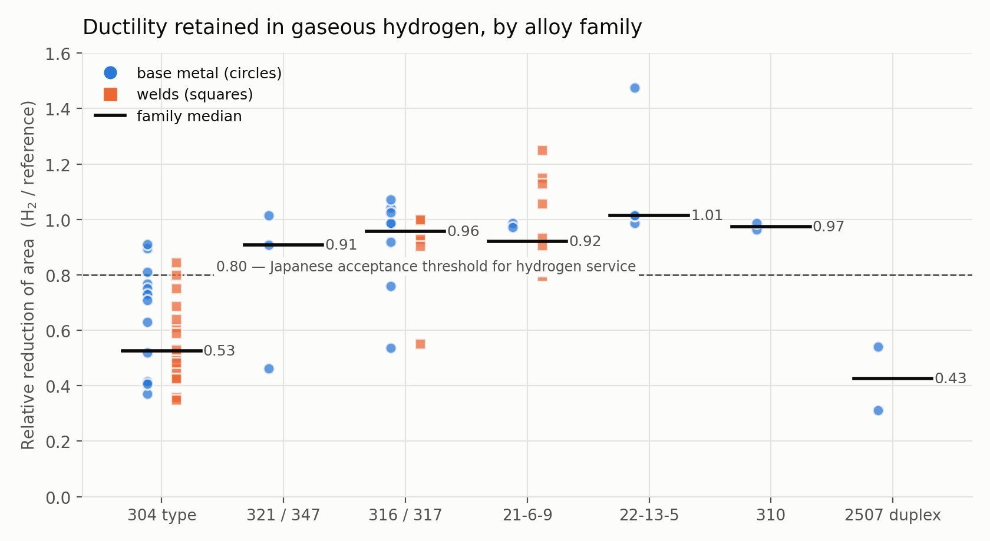
Figure 1. Relative reduction of area in gaseous hydrogen by alloy family. Circles are base metal, squares are welds, horizontal bars are family medians. The dashed line at 0.80 is the value at which Japanese regulatory practice accepts an austenitic stainless steel for hydrogen service.
Table 2. Median relative reduction of area by alloy family, reduction-of-area records only.
Alloy family | n | Median RRA | Minimum | Maximum
Type 304 family | 34 | 0.53 | 0.35 | 0.91
Types 321 and 347 | 3 | 0.91 | 0.46 | 1.01
Types 316 and 317 | 14 | 0.96 | 0.54 | 1.07
21-6-9 | 14 | 0.92 | 0.80 | 1.25
22-13-5 | 4 | 1.01 | 0.99 | 1.48
Type 310 | 2 | 0.97 | 0.96 | 0.99
Duplex 2507 | 2 | 0.43 | 0.31 | 0.54
The ordering follows austenite stability rather than any single alloying addition. Type 310, with approximately 20 percent nickel, and the nitrogen-strengthened grades 22-13-5 and 21-6-9, in which nitrogen and manganese perform the role of nickel, retain their ductility. The type 304 family, whose austenite transforms under strain, does not. Duplex 2507 is the most severely affected material in the set, as expected of a microstructure that is approximately half ferrite.

4.2 Welds compared with base metal
Table 3. Median relative reduction of area by weld zone.
Zone | n | Median RRA | Interpretation | Note
Base metal | 36 | 0.85 | Moderate loss | Reference condition
Whole welded joint | 24 | 0.83 | Moderate loss | Gauge spans parent, HAZ and fusion zone
Weld metal only | 14 | 0.49 | Significant loss | Gauge is entirely weld deposit
The pooled column in Table 3 should not be read as a zone effect on its own. The 36 base-metal records span eight alloy families and seven sources; the 24 whole-joint records come from a single source and three families; the 14 weld-metal records come from three sources and two families, and 12 of the 14 are type 304 family. Within family the comparison is cleaner: in the type 304 family base metal has a median RRA of 0.72 (n = 14) against 0.48 for weld metal (n = 12), and in types 316 and 317 it is 0.99 (n = 8) against 0.73 on two weld records. The whole-joint values lie close to base metal because deformation in such specimens localises in the more ductile regions; any test geometry that permits this will understate the susceptibility of the weld itself.
Balch et al. [3] demonstrate the effect within a single weld. Reduction of area in the as-welded condition is 77 to 83 percent at all three heights of a multipass 304L/308L joint. After charging at 138 MPa to 7700 appm hydrogen it falls to 28 to 41 percent, the lowest value occurring at the weld root, where the metal has experienced the most reheating from subsequent passes.

4.3 Delta ferrite
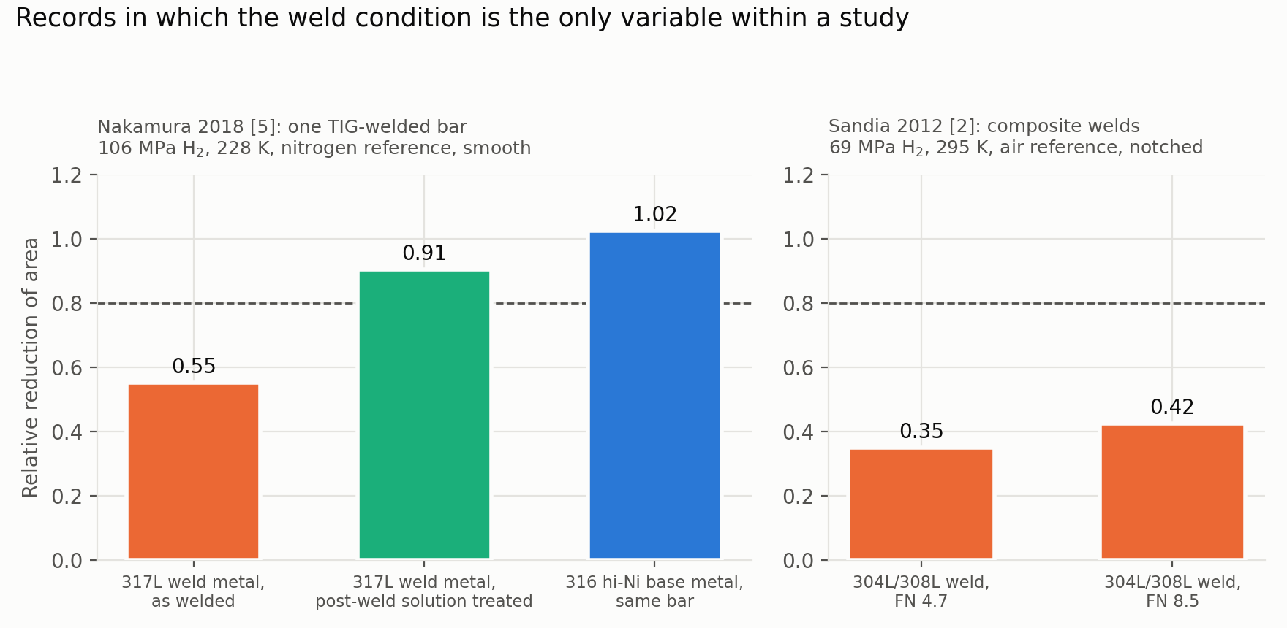
Figure 2. Relative reduction of area for weld metal in hydrogen gas. The three left-hand bars are one TIG-welded bar tested at 228 K in 106 MPa hydrogen [6]; the two right-hand bars are notched composite 304L/308L welds at two ferrite numbers tested at room temperature in 69 MPa hydrogen [2].
Nakamura et al. [6] tested a single TIG-welded bar in three conditions at 228 K in 106 MPa hydrogen, against a nitrogen reference. The parent 316 (hi-Ni) gave RRA 1.02. The 317L weld metal gave 0.55 in the as-welded condition, in which coarse columnar dendrites contain delta ferrite, and 0.91 after a post-weld solution treatment that dissolves the ferrite. The authors report lamellar fracture features associated with the ferrite in the as-welded condition and fully dimpled surfaces after solution treatment. Since the alloy, the gas, the pressure and the temperature are common to all three conditions, the delta ferrite is the operative variable.
A second and weaker comparison is available from the Sandia type 304 chapter [2], in which notched composite 304L/308L welds at ferrite numbers of 4.7 and 8.5 tested in 69 MPa hydrogen gave RRA 0.35 and 0.42 respectively; here the higher ferrite content gave marginally better retained ductility. The two observations are not necessarily contradictory, since the Sandia specimens were notched and the ferrite range is narrow, but a single pair of tests does not establish a trend and is not presented as one.
This is where the restriction to gaseous exposure is most limiting. Electrochemically charged studies consistently report that delta ferrite raises susceptibility and that its morphology matters, lathy ferrite being more damaging than skeletal [13]. Whether that ordering survives at service pressures in gas is not resolved by the data assembled here, because the one study that measured it in gas [12] published its results only as a figure.

4.4 Hydrogen pressure
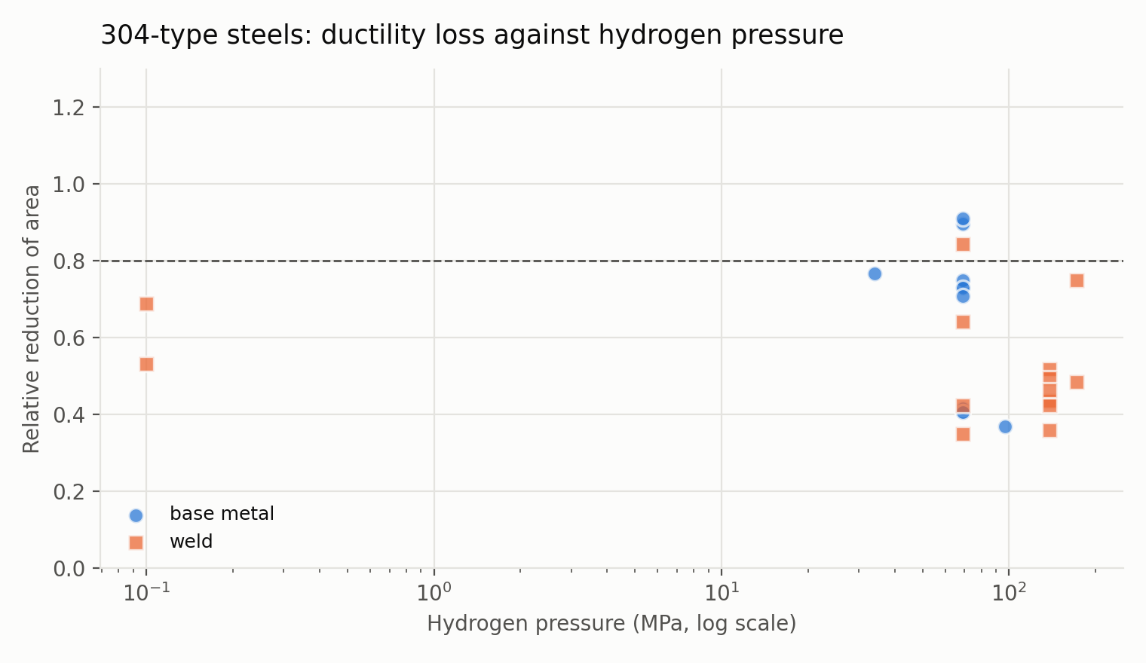
Figure 3. Relative reduction of area of type 304 family steels against hydrogen pressure on a logarithmic axis, separated into base metal and welds.
Within the type 304 family the median RRA of records at 69 MPa and above is 0.49. Caskey [1] observes that tensile ductility falls steeply up to approximately 14 MPa and then more gradually to 69 MPa, which is consistent with the distribution of the present data, although the dataset is too sparse below 30 MPa to support fitting.

5. Limitations
The dataset is small. One hundred and thirteen records, of which 74 give a relative reduction of area, is enough to characterise the well-studied grades and no more; the stabilised grades are represented by three records and duplex by two, so those family medians are indicative only.
Data reported only in figures is absent, and the omissions are not random: they include the two studies most directly relevant to the delta ferrite question. The present release therefore documents the weld problem more successfully than it explains it.
Reference environments are mixed. Forty-eight records are referenced against air, 28 against high-pressure helium, 32 against the uncharged condition and five against nitrogen or argon. A helium reference at the test pressure isolates the chemical effect of hydrogen from the mechanical effect of pressure; an air reference does not, and will slightly overstate the loss. The field is recorded so that users may filter on it, but the medians reported above do not.
Verification is partial: 24 of 113 records have been independently re-extracted, and the remainder have passed automated consistency checks only. Several sources report a single test per condition, so no uncertainty is recorded because none was published. Finally, records taken from the two handbooks are one step removed from the original experiments; both cite their primary sources, and those citations are preserved in the dataset, but the values were read from the handbook tables.

6. Conclusions
Across the gaseous hydrogen literature compiled here, weld metal retains approximately half of its ductility (median RRA 0.49, n = 14) while base metal retains most of it (0.85, n = 36). That pooled contrast overstates the zone effect, because the weld-metal population is almost entirely type 304 family while the base-metal population includes the more stable grades. Within the type 304 family the comparison is 0.48 for weld metal against 0.72 for base metal, and within types 316 and 317 it is 0.73 against 0.99 on two weld records. The zone effect survives the correction; its size does not. Specimens that span a whole welded joint behave like base metal and conceal the difference.
The alloy family ordering follows austenite stability, and the nitrogen-strengthened grades achieve the resistance of high-nickel austenitics without their nickel content.
A post-weld solution treatment that dissolves delta ferrite raised the relative reduction of area of 317L weld metal from 0.55 to 0.91 in 106 MPa hydrogen at 228 K, which identifies delta ferrite rather than weld metal composition as the controlling factor in that case. The relationship is not settled. The two records in this dataset that carry a measured ferrite number order oppositely, FN 4.7 giving 0.350 against FN 8.5 giving 0.425 in notched specimens, and Hirata [10], which tested ten weld metals in 45 MPa hydrogen gas but reports the result only in figures, concludes that austenite stability expressed as Md30 or nickel equivalent, and not delta ferrite, governs weld-metal embrittlement. With ferrite number populated for 2 of 113 records, this dataset cannot adjudicate between the two readings and should not be used to.
Only 14 weld metal records exist in the entire open literature that meet a gas-exposure criterion. That scarcity, rather than any result reported here, is the principal finding.

7. Data availability
The dataset, the extraction and analysis code and the figures are available at https://github.com/mfaizansworkspace-ai/Hydrogen-Embrittlement-in-Austenitic-SS and archived on Zenodo under the DOI issued for release 1.0. Data are released under CC BY 4.0 and code under the MIT licence. Corrections are invited: reports should quote the record identifier, the value in the dataset, the value read from the source and the table it came from.

8. Declarations
The author declares no competing interests. No funding was received for this work. The dataset contains values extracted from published tables and does not redistribute copyrighted material.

9. References
[1] Caskey GR Jr. Hydrogen compatibility handbook for stainless steels. Report DP-1643. Aiken (SC): Savannah River Laboratory; 1983.
[2] San Marchi C, Somerday BP, editors. Technical reference on hydrogen compatibility of materials. Report SAND2012-7321. Livermore (CA): Sandia National Laboratories; 2012.
[3] Balch DK, San Marchi C, Somerday BP, Ronevich JA. Effect of hydrogen on tensile strength and ductility of multipass 304L/308L austenitic stainless steel welds. In: Proceedings of the ASME 2015 Pressure Vessels and Piping Conference. Paper PVP2015-45591. Boston (MA); 2015.
[4] Ronevich JA, Somerday BP, San Marchi CW, Balch DK. Fracture threshold measurements of hydrogen precharged stainless steel weld fusion zones and heat affected zones. In: Proceedings of the ASME 2015 Pressure Vessels and Piping Conference. Paper PVP2015-45432. Boston (MA); 2015.
[5] Michler T, Lee Y, Gangloff RP, Naumann J. Influence of macro segregation on hydrogen environment embrittlement of SUS 316L stainless steel. Int J Hydrogen Energy. 2009;34(7):3201-9.
[6] Nakamura J, Okazaki S, Matsunaga H, Matsuoka S. SSRT and fatigue life properties of 317L austenitic stainless steel weld metal in high-pressure hydrogen gas. Trans JSME. 2018;84(857):17-00437. Japanese.
[7] Younes CM, Steele AM, Nicholson JA, Barnett CJ. Influence of hydrogen content on the tensile properties and fracture of austenitic stainless steel welds. Int J Hydrogen Energy. 2013;38:4864-76.
[8] Iyer KJL. The influence of hydrogen on the mechanical properties and structure of a stable 304 stainless steel. Can Metall Q. 1989.
[9] Fukunaga A. Hydrogen embrittlement behaviors during SSRT tests in gaseous hydrogen for cold-worked type 316 austenitic stainless steel and iron-based superalloy A286 used in hydrogen refueling station. Eng Fail Anal. 2024;160:108158.
[10] Matsuoka S, Yamabe J, Matsunaga H. Hydrogen-induced ductility loss of austenitic stainless steels for slow strain rate tensile testing in high-pressure hydrogen gas. Solid State Phenom. 2017;258:259-64.
[11] Yamabe J, Takakuwa O, Matsunaga H, Itoga H, Matsuoka S. Hydrogen diffusivity and tensile-ductility loss of solution-treated austenitic stainless steels with external and internal hydrogen. Int J Hydrogen Energy. 2017;42(18):13289-99.
[12] Hirata K. Effects of chemical compositions and microstructure on hydrogen embrittlement of austenitic stainless steel weld metal in a high-pressure gaseous hydrogen environment. Weld Int. 2015;29(12):922-7.
[13] Zhou C, Ye R, Liu H, Zhang L, Zheng J. Effect of the ferrite morphology on hydrogen embrittlement of MAG welded 304 austenitic stainless steel. Appl Surf Sci. 2022;606:154866.
[14] Zhang L, Wen M, Imade M, Fukuyama S, Yokogawa K. Effect of nickel equivalent on hydrogen gas embrittlement of austenitic stainless steels based on type 316 at low temperatures. Int J Hydrogen Energy. 2013;38:11181-7.
[15] Neuharth JJ, Cavalli MN. Investigation of high-temperature hydrogen embrittlement of sensitized austenitic stainless steels. Eng Fail Anal. 2015;51:1-8.

